

Moston Parish Council

11th September 2024
Commenced: 7.30 pm Terminated: 8.25 pm

Present: Councillor Nixon (Chair)
Councillors Bower-Lowe, Haigh and Tumilty
Councillor Wray – Cheshire East Councillor

There were 5 Members of the Public in attendance

- APOLOGIES FOR ABSENCE
Apologies for absence were received from Councillors Luckett and Moran.

- DECLARATIONS OF INTEREST
There were no declarations of interest received from Members of the Parish Council.

- MINUTES

The Minutes of the proceedings of the Meeting of the Parish Council held on 3rd July 2024 were approved as a correct record and signed by the Chair.

- PUBLIC FORUM
A Member of the Public raised the very busy traffic on the corner of Watch Lane and also on Red Lane, which was continuing to increase.

FINANCE AND BUDGET 2024-2025
Members considered a report of the Clerk and Responsible Financial Officer.

- Transactions since 25th June 2024
RESOLVED
That the following transactions be approved:-

PAYEE/PAYER | DETAILS | RECEIPT | PAYMENT | BALANCE
M Clough | June Salary |  | £230.13 | £20,630.98
HMRC | PAYE June |  | £57.60 | £20,573.38
Dave Nixon | Reimbursements |  | £27.47 | £20,545.91
Information Commissioner | Annual Fee |  | £35.00 | £20,510.91
M Clough | July Salary |  | £230.33 | £20,280.58
HMRC | PAYE July |  | £57.40 | £20,223.18
M Clough | August Salary |  | £230.13 | £19,993.05
HMRC | PAYE July |  | £57.60 | £19,935.45

- Approval of Payments
RESOLVED
That the following payments be approved:-

Salary | Clerk | September – Month 6 | Approx. £230.13
Salary | PAYE Clerk | September – Month 6 | Approx. £57.60
Salary | Clerk | October – Month 7 | Approx. £230.13
Salary | PAYE Clerk | October – Month 7 | Approx. £57.60
Microsoft Office | Annual Subscription |  | £59.99

- 2024-2025 Budget Expenditure at 31st August 2024
RESOLVED
- That the following Budget Head 2024-2025 expenditure be approved:-

Budget Head | Total | Budget Allocated | £ Balance
Salary | £1,438.65 | £3,800.00 | £2,361.35
General Admin | £62.47 | £250.00 | £187.53
Website/ICT Costs | £528.00 | £550.00 | £22.00
Insurance | £251.97 | £625.00 | £373.03
Payroll Costs | £82.80 | £300.00 | £217.20
Audit Fees (Internal) | £126.00 | £150.00 | £24.00
Subscriptions | £106.40 | £395.00 | £288.60
Meeting Room Hire | £50.00 | £150.00 | £100.00
Training | £0.00 | £100.00 | £100.00
Parish Improvements/Events | £308.00 | £1,000.00 | £692.00
Chair's Fund | £0.00 | £30.00 | £30.00
 | £2,954.29 | £7,350.00 | £4,395.71

- Resolved that the Chair purchases three oak trees to a maximum of approximately £100.00.

- Explanation of Variances
The Clerk reported that there were no variances to the Budget to consider.

RESOLVED
That the report be noted.

- Bank Reconciliation as at 31st August 2024
RESOLVED
That the following Bank Reconciliation as at 31st August 2024, be approved:-

Bank Reconciliation
31st August 2024
MOSTON PARISH COUNCIL
Financial year ending 31 March 2025
Prepared by: Muna Clough, Parish Clerk & RFO
Balance per bank statements as at 31st August 2024
CASH BOOK
Opening Balances at 31st August 2024
Current Account 07572433 |  | £19,935.45
Reserve Account 96473193 |  | £5,141.38
Less Payments not Cashed |  | £0.00
Add Unbanked Cash |  | £0.00
Net bank balances as at 31st August 2024 |  | £25,076.83
The net balances reconcile to the Cash Book (receipts and payments account) for the year, as follows
Current Account @ 01.04.2024 |  | £18,884.84
Reserve Account @ 01.04.2024 |  | £5,109.84
Add: Receipts in the year - Current Account | £4,004.90 | £22,889.74
Add: Receipts in the year - Reserve Account | £31.54 | £5,141.38
Less: Payments in the year - Current Account | £2,954.29 | £19,935.45
Less: Payments in the year - Reserve Account |  | £5,141.38
Closing balance per cash book [receipts and payments book] must equal net bank balances above |  | £25,076.83

GOVERNANCE 2024-2025
RESOLVED
That the following Policy documents be approved (all documents were circulated with the Agenda):-

(i) Standing Orders 2024-2025

(ii) Policy for the Retention of Documents 2024-2025

GDPR Policy

(iv) Publication Scheme 2024-2025
(v) Financial Regulations 2024-2025
(vi) Code of Conduct 2024-2025

RISK ASSESSMENT 2024-2025
RESOLVED
That the Risk Assessment for 2024-2025, appended to these Minutes as Appendix 1, be approved.

ASSET REGISTER 2024-2025
RESOLVED
That the Asset Register for 2024-2025, appended to these Minutes as Appendix 2, be
approved.

PLANNING APPLICATIONS
The Parish Council to consider an update from Councillor Nixon on the following:-

- New Planning Applications

(i) Planning Reference 24/3066D Location: Glebe Farm, Booth Lane, Moston, Middlewich Proposal: Discharge of condition 16 on approval 20/5700C: Reserved Matters application for appearance, landscaping, layout & scale following outline approval 21/2600C for 390 dwellings, retail unit, public open space and associated works. Moston Parish Council strongly opposed the original application. This application was approved by the planning officer but Cheshire East Council had not altered the date for comments.

(ii) Planning Reference 24/2627C Brunello Red Lane.
Proposal: Proposed first floor extension and alterations. The Chair and Clerk looked at this application and commented under Standing Order 5 - Urgent Business. There were no objections submitted on behalf of the Parish Council.

- Recent Decisions
  - Planning Reference 24/2174C Location: The Cottage, Red Lane, Moston, Cheshire CW11
3PE. Proposal: Change of use from C3 dwelling to C2 Residential institution caring for up to 2 children under 18 years old.

This application was granted on 5th September 2024. Moston Parish Council did not object to the application, but for the safety of all concerned, the location had to be considered. The entrance to The Cottage was situated in a dangerous location close to the junction with Hall Lane, adjacent to Newfield Fabrications Staff Car Park and nearly opposite their HGV exit/entry. Red Lane was narrow and traffic entering the Lane from Hall Lane did so at considerable speed. The four parking spaces outlined within the application did not seem adequate, as there could be four vehicles during the changeover of staff and more if support workers, local authority staff or any maintenance work was required. More parking spaces needed to be added with sufficient room for vehicles to turn round within the site. The Parish Council considered that if planning was granted a condition was required that No Parking was allowed on Red Lane and further consideration given to double yellow lines on the carriageway. Highways did not object. The planning application was granted with no conditions regarding parking restrictions.

  - Planning Reference 24/23399C Location: Hillcrest, Warmingham Lane, Moston.
Proposal: Single storey Rear Extension. The Chair and Clerk looked at this application under Standing Order 5 and commented that Moston Parish Council did not object to the application. There did however, appear to be a lack of information and measurements on the plans were described as indicative only. It was difficult to find the exact height of the proposed extension, it would seem to be 2.75 metres plus the Lantern Roof a further 0.25 metres in height, but it was not possible to find the dimensions. It was considered that great care needed to be taken to not negatively impact the amenity of the attached bungalow and the indicative measurements would be the maximum. Planning was granted on 4th September 2024.

  - Planning Reference 24/0191C Location: Pitch 12, Land at, Dragons Lane, Moston, CW11 3QB. Proposal: Change of use of land to form 1 gypsy and traveller family pitch, along with the erection of 1 day room with access taken off Dragons Lane. This application was refused on 22nd August 2024.

  - Planning Reference 24/0596C Location: Land North Of Junction With Mill Lane, Warmingham Lane, Moston, Cheshire East, CW11 3PT. Proposal: Full planning application for removal of concrete lagoons and structures and redevelopment of site to provide a single detached dwelling. General approval of the plans. The Parish Council supported the application but the proposal was refused on 1st July 2024. It was understood that the applicant would appeal against the decision.

- Ongoing Planning Applications

  - Planning Reference 24/0275C Location: Stud Green House, Dragons Lane, Moston, CW11 3QB Proposal: Single Storey Side Extension. The Canal and River Trust had submitted a reservation. Work appeared to be continuing on the side extension.

  - Planning Reference 24/0884C Location: Moston Garage, Booth Lane, Moston, Cheshire, CW11 3PU. Proposal: Change of Use from garage to vehicle storage with ancillary office and garage workshop with wash down area. Objections had been submitted by Flood Risk and the Environment Agency. Environmental Protection felt there was a lack of information submitted. Work appeared to have stopped on site.

  - Planning Reference 23/4026C Location: Thimsworra Farm, Dragons Lane, Moston, CW11 3QB. Proposal: Change of use of land to use as a residential caravan site for 7 gypsy families with a total of 16 caravans, including no more than 7 static/mobile homes, together with laying of hardstanding, erection of communal amenity building, erection of 5No utility buildings and erection of stable building. Comments had been received from the Environment Agency. The application would be considered by the Southern Planning Committee on 23rd October 2024.

  - Planning Reference 23/3570/C Location: Land south of Warmingham Lane. Proposal:
Change of Use of land for use as a natural burial ground for the burial of coffins and urns with associated infrastructure. No progress had been made on the application.

  - Planning Reference 23/3408C Location: Land off Warmingham Lane, Moston. Proposal: Erection of agricultural building. An objection had been submitted from United Utilities. This application remained undecided.

  - Planning Reference 22/3244C Location: Fairacre, East Booth Lane, Moston, CW11 3PU. Proposal: Change of use of land for Showmans Yard with facilitating development (hardstanding, fencing, septic tank) retrospective. It was expected that Cheshire East Council would grant planning permission but the objection from the Environment Agency is still effective.

- LIBRARY CONSULTATION
The Chair reported on the proposed closure of libraries and the impact of the closure of the library in Sandbach on the local residents. Members felt that the decision had already been predetermined.

RESOLVED
That the Parish Council opposes the closure and the Clerk to submit the comments on the proposals.

- CHAIR’S REPORT
The Chair reported that the broadband issues were making little, if any, progress.

In response to a question, Councillor Nixon reported that an area on Plant Lane, next to the canal was being used by motorhomes, mainly from Europe for free overnight camping.

The Chair referred to a complaint received from a resident of Albion Lock Estate, relating to dips on the highway on Booth Lane, the road which was causing various concerns to the residents. This matter had been referred to Cheshire East Council.

RESOLVED
That the report be noted.

- REPORT FROM CHESHIRE EAST COUNCILLOR
Councillor Wray reported on a number of cost cutting/financial saving measures including the restructure of senior officers at Cheshire East Council over the last 12 months. There had been changes to the postholders of Monitoring Officer; Finance Manager; Head of Children Services; Chief Executive.

Councillor Wray also reported that ANSA was to be dissolved and its services brought back into Local Authority control.

RESOLVED
That the report be noted.

- DATE OF NEXT MEETING
Members noted that the next meeting of the Parish Council would be held on Wednesday, 13th November 2024 at 7.30 pm at St. Peter’s Church Hall, Elworth, Sandbach, CW11 3HU.

APPENDIX 1
Moston Parish Council Risk Assessment 2024-2025

Identified Risk | Potential consequence of risk | Assessment of impact (H/M/L) | Likelihood of risk occurring (H/M/L) | Controls in place to manage risk | Required Action
Loss or damage of physical assets owned by the Council. | Assets unable to be used. Expense of replacing assets. | H | M | An up to date register of assets.  Adequate insurance of assets. | Regularly update register of assets and review insurance accordingly.
The risk of damage to third party property or individuals as a consequence of the Council providing services or amenities to the public. | Risk of litigation should an individual or third party property become injured or damaged. | H | M | Public liability insurance.  Continue to report the failure of services and amenities to the public to the relevant authority. | Annual review of Public Liability Insurance cover
Loss of cash through theft or dishonesty. | The Council may be unable to provide its services.  Damage to reputation of the Council. | H | L | Regular bank reconciliations are carried out. Internal audit carried out annually. | All payments detailed at Council Meetings.
Security and maintenance of documents and equipment. | Risk of loss of council records or property. | H | L | Documents backed up and Officer equipment safely stored when not in use. | Regular back up of laptop documents and website.
Compromised banking arrangements, including borrowing or lending as they are inadequate. | Loss of income through poor investment of funds. Bank charges incurred through unauthorised borrowing. | L | L | Regular bank reconciliations are carried out before each Council meeting.  The budget is monitored each month and balances are transferred between the deposit account and current account.
Inaccuracies in Financial records | Public criticism by reviewer of accounts leading to reputational challenges | M | L | Cash book is maintained throughout the year. At the year end, financial statements are produced from the cash book and adopted by the Council.  The bank reconciliation is presented to all meetings.  All invoices and payments are now stored on the cloud. | Continue to formally receive financial statements at every meeting of the Parish Council
Failure to ensure all business activities are within legal powers applicable to local councils. | Ultra-vires expenditure could lead to local elector challenge. Possible external auditor investigation / public interest report. This would result in increased fees and bad publicity for the Council. | M | L | All payments are authorised by the Council at Council meetings.  CHALC Membership | The Minutes record all decisions taken and payments made.  Ensure Clerk’s training is up to date.
Failure to ensure all requirements are met under employment law and HMRC regulations. | Fines for not meeting requirements.  Liability for unpaid tax. Risk of legal action from employee. | M | L | Payroll records maintained each month.  Parish Clerk has contract for employment which is reviewed annually.  Annual payroll returns are submitted on time via Shires payroll.  Employment contract for Parish Clerk is approved by Council.
Failure to ensure all requirements are met under Customs and Excise regulations. | Entitlement to reclaim of VAT for a period being lost. | M | L | VAT is analysed separately in the cash book.  VAT invoices are retained.  VAT returns are submitted at least annually.
Failure to ensure the adequacy of the annual precept within sound budgeting arrangements. | The Council would not be able to meet its objectives due to lack of funds. | H | L | The Council set a budget annually in the annual budget meeting.  Actual expenditure against budgeted expenditure is reported to Council at each meeting.
Failure to adopt timely and accurate reporting of council business in the minutes. | The Council could be open to challenge if they do not have an accurate record of any decisions taken. | L | L | Minutes are taken at each Council meeting by the Clerk, these are properly numbered and are approved at the next Council meeting. | To deliver the signed Minutes to the Cheshire Records Office on an annual basis.  Ongoing training of the Clerk as recommended by CHALC
Failure to respond to electors wishing to exercise their rights of inspection. | An elector could complain if they are not able to exercise their right of inspection. | L | L | A notice is put up on Council website notifying electors of their right to inspection of the accounts during the relevant inspection period.
Inadequate document control. | Increased fee from the internal auditor or external auditor if there is a poor audit trail. | L | L | All documents are filed. There is an audit trail from the cash book to supporting documentation. | Respond to any comments/recommendations from the Auditor
Register of members’ interests and gifts and hospitality isn’t in place, complete, accurate or up to date. | Possible complaint by elector. | L | M | All members have adopted the code of conduct. | Ensure all new Members are clearly briefed about the requirements  Annual reminders to all Members to check/update their interests
Disaster Recovery not in place | Loss of essential records | H | L | Secure online data storage.
Any circumstance affecting the Council's ability to hold regular meetings | Inability to conduct council business due to not being able to hold face:face meetings | H | L | Hold meetings remotely where this is legal | Follow advice from CHALC
Supplier fraud including the adequacy of supplier onboarding controls | Loss of finances from goods paid for but not received | M | M | Most costs are only incurred after goods received  Extra research if payment is to be made in advance
Parish Council inquorate | Too few councillors | M | M | Immediate and extensive recruitment  Positive and extensive publicity of vacancies  CWAC support  Monitor and manage as appropriate | Members of Parish Council
Loss of Property | Damage including third party or criminal damage | M | M | Review adequacy of Insurance Cover | Annual reviews
Staff not in place | Essential works not carried out  Fraud by Staff | M  L | M  L | Hours, health/long term illness, training, resignation.  Monitor and manage as appropriate.  Fidelity guarantee value set at appropriate level | Continual membership of CHALC who will provide temporary support if required.

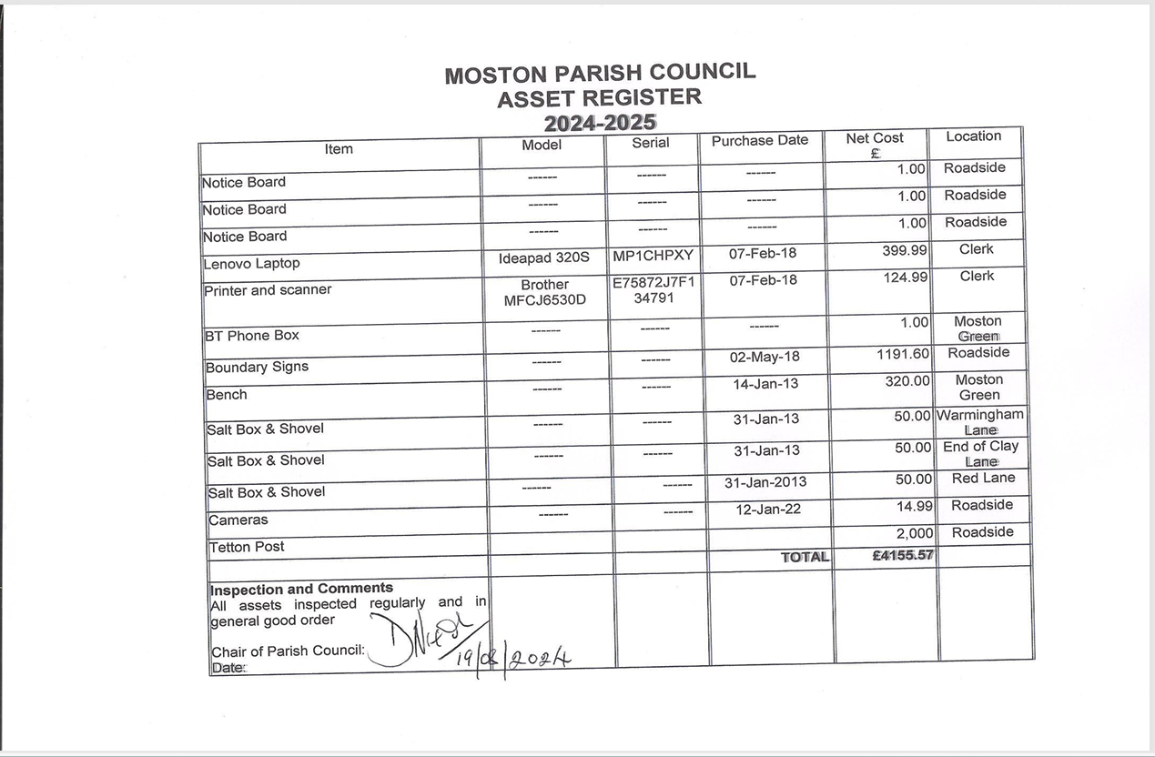
APPENDIX 2

